FND14

# iterative.c source code

# iterative.c output when x = 5

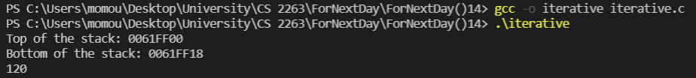

Memory consumption: 0061ff18 – 0061ff00 = 18

# iterative.c output when x = 10

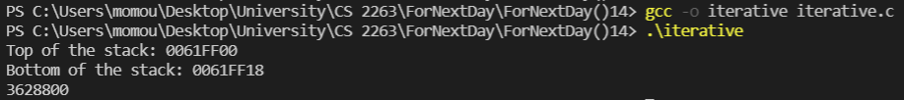

Memory consumption: 0061ff18 – 0061ff00 = 18

# iterative.c output when x = 15

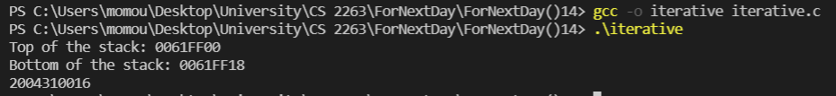

Memory consumption: 0061ff18 – 0061ff00 = 18

# recursive.c source code

# recursive.c output when x = 5

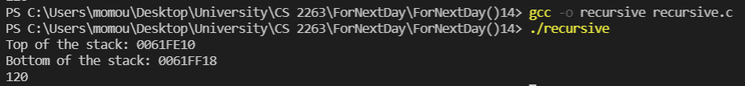

Memory consumption: 0061ff18 – 0061fe10 =108

# recursive.c output when x = 10

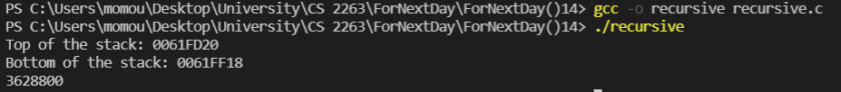

Memory consumption: 0061ff18 – 0061fd20= 1f8

# recursive.c output when x = 15

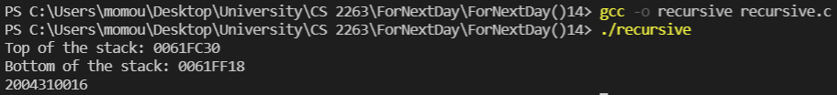

Memory consumption: 0061ff18 – 0061fc30 = 2E8

Using the iterative method was more efficient than using the recursive method. The memory consumption, on one hand, during iteration was the same regardless of the input because we did not add stack frames. On the other hand, input (value of x) did matter significantly. The more the value of x was, the more stack frames we had to add, leading to memory consumption.